| bslgoclr TROOP 314 NEWS **MAY 2014 AD** **Edition** | http://orangefrontier.ocbsa.org/sites/default/files/OFDpatch.gif IN THIS ISSUE:   * Scoutmaster’s Corner * SPL Corner * Troop Events of last month * Troop Calendar * Reports/Upcoming Events * + * And **Much More!** * **Contact Editor at: t314news@live.com** |
| --- | --- |
| *BSA Troop 314 / Orange Frontier District*  *Westminster, (Midway City) C**alifornia* | *Sponsored by: Albert E. Schwab*  *American Legion Post 555*  (Midway City) |

###### Description: http://tbn0.google.com/images?q=tbn:sSD--S7PVbA3pM:http://www.bsatroop625.org/img/sm_patch.jpgScoutmaster’s Corner

Congratulations to the Troop 314 Golden Spoon team. As I'm sure you will read elsewhere in this newsletter, they came away from Camporee with the 2nd Place Award. Prepared by Mrs. Hight, and led by Alex B, they cooked the mystery ingredients, including the Brussels Sprouts (!), into a meal that must have impressed the judges!

Congratulations also go to the Bull Sharks Patrol, who ruled the "Know Your Campsite" event, wherein they had to set up a tent and campsite blindfolded. They won First Place in that event! Great job, guys.

And finally, congratulations to our Scouts who were selected by their Troop-mates to be candidates for the Order of the Arrow. They still have to go through their "Ordeal" before they are official, so I will hold off announcing their names.

In case you don't know, the Order of the Arrow is the National Honor Society of the BSA. The purpose of the OA is to promote service and camping, and to recognize those campers who best exemplify the Scout Oath and Law.

I would also like to thank all the Scouts and Scouters who helped out at the Scout-o-Rama, which took place on May 10. We put up the tower this year, which requires plenty of planning, and help on Friday as well as Saturday. We got lots of kudos on our tower from the Scout-o-Rama staff. We put 62 youngsters up on the tower, and hopefully they will remember Troop 314 when it comes time to choose a troop. We did our best to send each one away with a flyer -- thanks go to Mr. Tran for creating and printing those flyers.

This month we will be preparing for a Belt Loop Day which we will be holding in June. This is another event that will require lots of help, but it has the potential to attract lots of new members. So remember the 3rd point of the Scout Law (Helpful), and volunteer!



Thanks again to all,

***Richard Marubayashi, Scoutmaster, Troop 314***

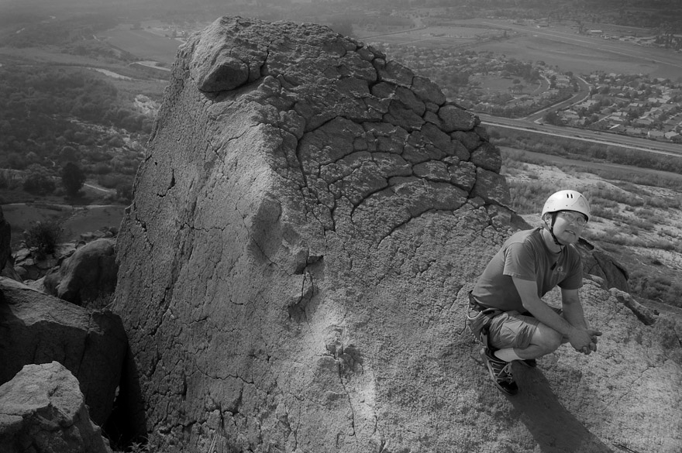

[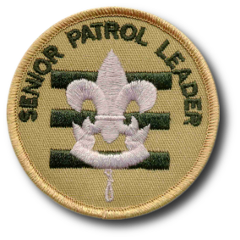](http://meritbadge.org/wiki/images/7/75/SPL.)**SPL Corner**

Hello Troop 314 Scouts!

Well for us JLC leaders, our term of service is coming near an end, and so is the school year.

We have made it through another successful Camporee – Bull Sharks won First Place in “Know your Camp” competition! And a big Thank You to all our Scouts who participated in the Camporee events. I want to give a special thanks to Alex Bloch for leading our Troop in the Golden Spoon, and to Mrs. Hight for holding our practice cook off. We placed second out of 10 cooking teams – not bad at all.

We also had a pretty good recruitment event this weekend at Scout-O-Rama – While not as tasty as our usual donuts, it did seem our Tower got a lot of positive attention and hopefully brings some Webelos into the troop.

Our meeting’s theme for the next couple months is to plan and execute a Cub Scout Belt loop day – Probably looking at 10 skills with 2 Scouts to a skill. So you might want to look up the belt loop requirements before the next meeting on the 13th. Rocking Chair can do the cooking. Thanks!

Let's finish these last two months strong!

***Your SPL, Noel J.***

sq-rope

**THINGS TO REMEMBER TO DO THIS MONTH:**

* **Wish Martin L. a “Get Well Soon” for his injured knee.**
* **June 24th is a Court of Honor - now is time for each patrol to pick the theme for your opportunity drawing basket**.
* **Scouts and Adults Get Your Medical Forms Part A and B forms completed and see an MD for Part C needed for Summer Camp!.**

**PLEASE use the latest version: 680-001, 2014 PLEASE DO NOT USE AN OLD FORM. It causes a lot of needless headaches.**

**Get them here:**   
  
<http://www.scouting.org/scoutsource/outdoorprogram/standardsandforms/medicalformfaqs.aspx>

* **Attend a Meeting with your Patrol.**

****

**CAMPOREE 2014**

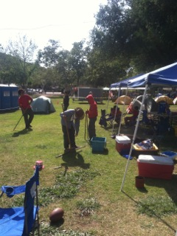

Camp Fun, Scout Style - involves sticks.

******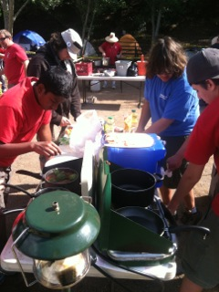

Golden Spoon Cook off Crew at work

***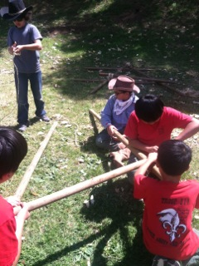***

Blue Phoenix executes some strong lashings, very fast – really impressive to watch.

***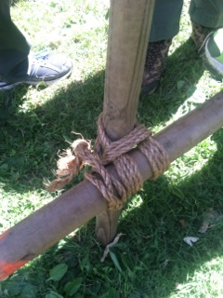***

***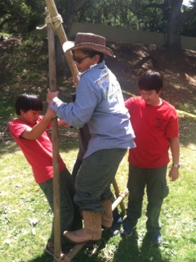***

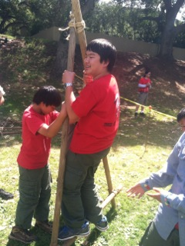

Load testing

***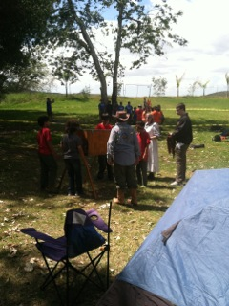***

B P work blind.



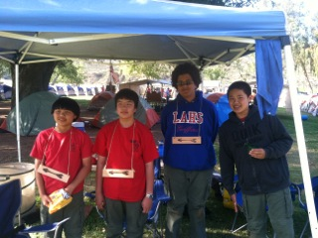

Long T. and his Order of the Arrow strikes again.

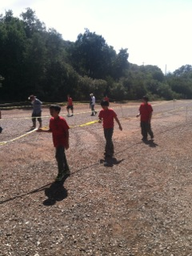

 This Frisbee competition was really hard.   
**sq-rope**

**Troop 314 Service Projects:**

j0105172The Troop has an open position for an Adult Service Project coordinator –

Parents - If you can help out to plan and file a tour permit, please let Mr. Hilton know!

We have some ideas floated at JLC for Troop Service projects:

First Saturday Stewards (at El Dorado Park Nature Center), the Orange County Food Bank, Ronald McDonald House, and Beach (Bolsa Chica) Cleanup.

sq-rope

**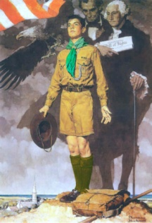Uniform Inspections**

In order to get great score for Camporee Uniform inspections - these will occur at every troop meeting. "Opportunity drawing" tickets will be awarded for correct uniforms and prize drawings will occur at the last meeting of the month.

**Order of the Arrow**

**Wiatava Lodge (#39) Santee Chapter News**

July- Day Camp with 200 attendants in 2014oa_logo_16x16

***Long T.OA, Representative***

**sq-rope**

**Troop 314 Scribe –**

**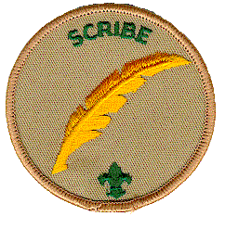**

**Junior Leadership Committee (JLC) Minutes for**

**May 6, 2014 AD.**

Leaders in attendance:

Gabe B., Elijah B., Joseph G., Noel J., Ian M., Long T., Mr. Bess, Mr. Marubayashi, Mr. Pearson, and Mrs. Hight

Long T. acted as Troop Scribe at this meeting.

* **The troop will be planning to do Belt Loop Day in June. The date might be on June 28th.**
* **In May, the troop plans for Belt Loop Day; and in June, the troop will practice to teach at Belt Loop Day.**
* **Two scouts may be worked together per requirement of a belt loop because there are three requirements for each belt loop.**
* **Each patrol must have a meeting each month.**
* Each patrol needs theme for basket and prepares the basket for June COH where we will have an opportunity drawing. The Patrol Leaders are expected to email their basket themes to the SPL by the week of the May 13th meeting.
* Cub Scout Day Camp is at St. Hedwig Church in Los Alamitos from July 28th to August 1st. Camp needs Boy Scout volunteers. Service hours can be earned 5 hours per day.
* Troop 610 will have a Merit Badge Day, date and location to be determined.
* Scout-O-Rama is on Saturday, May 10th.
* Elections on new positions will be on June 10th.
* Troop’s meeting will be at Bolsa Chica Park on June 17th. Scouts wear Class B uniform. Each patrol brings snacks.
* Homework burn will be determined at the next meeting.
* May 24th and 26th on Memorial Day Weekend, more information will be given about flag planting and Memorial Day events repectively.
* COH will be on June 24th and Gabe B. will MC.

May’s theme: Planning for Belt Loop Day

May 13th - Opening/set up – Blue Phoenix

Skill – Bull Sharks

Game – Scorpions

May 20th - Opening/set up – Scorpions

Skill – Blue Phoenix

Game – Bull Sharks

May 27th – Opening/set up – Bull Sharks

Skill – Scorpions

Game – Blue Phoenix

June 24th – Court of Honor

MC – Gabe B.

**[](javascript:edit(215563))**

***Viet T., Troop Scribe***

**sq-rope**

**BIRTHDAY BEST WISHES**

**For May 2014:**

***MCj03360900000[1]***

***Ian D. is 17 Years old on May 1st***

Happy Birthday, Scout!

sq-rope

**Troop Historian**

Last month Troop 314 participated in Camp O'ree to show how we tower above the rest. This year we did not construct the tower, instead we made an entrance to our campsite out of poles and our own lashings.

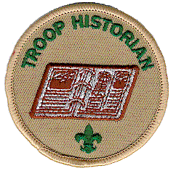This was the first Golden spoon the troop has participated in for many years. The group of eight boys consisted of Steven Y., Steven M., Michael M., Owen M., Robert P., Joseph G., Noel J., and I as the leader, and we placed second out of eight teams.

The Bull sharks patrol also received first place in the event of setting up a campsite blindfolded. I being the one who led golden spoon am very proud of the Scouts who came together to show how our troop really towers over the rest. Great job T314 I hope we do even better next year!

***Your Troop Historian,                                         Alex B.***

sq-rope

**Troop 314 Leadership**

* Senior Patrol Leader: Noel J.
* Assistant Senior Patrol Leader: Ian M.
* Blue Phoenix (RTFC) Patrol Leader: Gabe B.
* Scorpion (Mid-Young) Patrol Leader: David V.
* Bull Sharks (Mid-Old) Patrol Leader: Joseph G.
* Scribe: Viet T.
* Quartermaster: Elijah B.
* Librarian: Martin L.
* OA Representative: Long T.
* Chaplain’s Aide: Austin H.
* ****Historian: Alex B.

**Open Positions in Leadership**

* **j0105172Troop Guide: *\****
* **Den Chief: *\****

***Scouts - We need a Webelos Den Chief to attend Pack 314 meetings ~ once a month.***

***This is an important post to represent our Troop and help bring in Webelos II to Troop.***

***\* See Mr. M.*** ***for details on these jobs.***

**sq-rope**

**Patrol Advisors**

****Patrol Advisors help the Patrol Leader guide the patrol and improve their leadership skills.

The patrol leader should check with their advisor to plan patrol meetings and activities. If possible, the advisor should be present at patrol breakouts during the meeting to help plans go smoothly, and to oversee menus and other scout planning events.

****

**Blue Phoenix Patrol /   
Road To First Class (RTFC)**

– Mr. Bess / Mrs. Hight

**Scorpions** - Mr. Hallman

**Bull Sharks** - Mr. Feiffer

****

**Meeting Night Patrols**

Skill Patrol Leaders remember when you are planning the skills for the meeting, make sure that two levels of Skills should be worked out and that  
they are appropriate to the Troop Program Features Theme. It is best that everyone is (and can be) involved. When possible – see if a competition or game & competition can be made out of your skills.

The patrol that has flag ceremony /setup / cleanup should show up by 6:45pm (earlier if it’s a court of honor). It’s the patrol leader’s responsibility to make sure they do. ***This means picking up the phone to confirm communication received and understood****.*

Email or text are OK, but are not a substitute for direct bi-directional ***voice*** communication – a confirmed message transmission.

No one in the patrol should leave until everything is cleaned up and put away, or the patrol leader releases them.

Dutch Oven Cooking is only done during specified meetings. For example, Hot dogs and cooking are usually done when we have Webelos visit.

**blue_line_star.gif**

**Troop 314 is Camping Green**

Personal Mess kits are used on 99.889 % of Troop campouts – If in doubt, buy one and bring yours!

**blue_line_star.gif**

**The Troop can help you do something you always wanted to do!**

**Scouts – You have the Power to make some serious fun happen!**

**Just talk to Mr. Fieffer to get the ball rolling on one of these great activities, and while you are at it - step up to be Scout in Charge.**

**The Troop Committee will hook you up with the parents and resources to get it done!**

***Activities:***  **(bring your own too!)**

**Archery**

**Deep Sea Fishing -** Commercial Boat

**Ocean fishing** – Pier trip / Surf fishing

**Beach party**

**Annual Homework Burn Bonfire (June)**

**Bowling**

**Go Cart Racing (Family)**

**Hiking Trip**

**Backpacking -** Hike in camp in wilderness of Orange County or our mountain backcountry

**Snow Day -** at Grassy Hollow Visitors Center – Out of Wrightwood.

**Ski / Snowboard Trip**

**Lazer Tag (Family)**

**Air Soft Games (Family)**

**Paint Ball (Family)**

**Shooting Range** Could be a family or scout event depending what guns we want to shoot.

**BLM land / Desert Shoot –** High powered Rifle & Pistol shooting (Family event)

**Rock climbing** - Indoor Rock walls or natural climbs all work as we have 4 BSA Climb Instructors in this troop and our own climb gear/rope!

**Angel’s Baseball Game**

**Gold Prospecting**

**Swim –** Pool or Summer Beach Trip

**Scuba Instruction**

**Snorkeling / Beach Trip**

**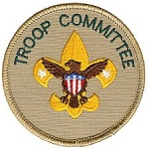White water rafting**

**Canoe River Trip**

**Annual Mistletoe Trip  
Annual Homework Burn!**

**Kayaking**

**Picnic / BBQ**

**Bring it on!**

***Mr. Fieffer, Activities Chair***

**Get out your Calendars and mark these dates!**

**TROOP EVENTS FOR MAY 2014 AD:**

**2nd First Friday at Post 555**

**Scouts signed up arrive at 6:00PM.**

**5th Executive Council Meeting @ Cypress Public Library 7 PM. - All Parents Welcome!**

**6th First Junior Leadership Council (JLC) Meeting 6:30 PM @ American Legion Post 555.**

****

**8th Orange Frontier District Roundtable**   
**LDS Church 4000 Orange Ave., Anaheim (2nd Thursday of each month)**

**10th Scout-O-Rama at Oak Canyon**

**11th Mother’s Day!**On behalf of the Bess family I wish all the Troop 314 mother and very very happy Mother’s Day. We all know, not much gets done without a mother's love and attention.  
  
– Mr. Bess

**13th Troop 314 Meeting at American Legion Post 555 starting at 19:00  
Camporee basic Scout Skills is focus this months meetings.   
Scoutmaster Conferences**

* **Setup and Flag - Blue Phoenix**
* **Skill - Bull Sharks**
* **Game – Scorpions**

**17th is ARMED FORCES DAY**

“President Harry S. Truman led the effort to establish a single holiday for citizens to come together and thank our military members for their patriotic service in support of our country.  On August 31, 1949, Secretary of Defense Louis Johnson announced the creation of an Armed Forces Day to replace separate Army, Navy, Marine Corps and Air Force Days. The single day celebration stemmed from the unification of the Armed Forces under the Department of Defense.”

(from <http://www.defense.gov/afd/> )

[](http://www.defense.gov/afd/images/ArmedForcesPOSTERproofFINAL_3613.jpg)

**20th Troop 314 Meeting at American Legion Post 555 starting at 19:00**

**Board of Review Night**

* **Setup and Flag - Scorpions**
* **Skill - Blue Phoenix**
* **Game - Bull Sharks**

**24th Memorial Day Weekend Saturday Flag Planting Details coming.**

**26th Memorial Day Services and Troop Wreath walk up. Details coming.**

**27nd Troop 314 Meeting at American Legion Post 555 starting at 19:00**

**Parent Meeting**

* **Setup and Flag – B.Sharks**
* **Skill – Scorpions**
* **Game B. Phoenix**

**Troop 314 Meeting Notes:**

* The Second Tuesday is Scoutmaster Conferences.
* The Third Tuesday meeting includes Board of Reviews for Rank Advancement.
* Fourth Tuesday Meeting of Month is usually Parents Meeting.
* No meetings are usually held on 5th Tuesday. These are saved for Fundraisers e.g.: Dinners.

**Court of Honors** are held 4 times a year, every three months – usually the last Scout meeting of month (except December).

In **March** and **September** Scouts are honored for their rank advancements with a candle lighting ceremony and parents are given pins. This tends to be a long ceremony, so no dinners.

In **June** and **December**, our COH does not have candles and rank advancement pins for parents, but we add a potluck dinner in June – (Optional potluck in Dec. usually kept simple due to constraints of time).

**UPCOMING EVENTS!**

**June 2nd Exec location moved due to election day. Could be at post.**

**June 3rd JLC meeting.**

**June 7th First Friday Dinner:**

|  |  |
| --- | --- |
| PATROL NAME | JUNE 7 |
| BLUE PHOENIX | MARTINL. |
| SCORPIONS | JON F. |
| BULL SHARKS | STEVEN M. |
| SPL/ASPL | NOEL J. |

**June 10th Troop Elections**

**June 17th Meeting held in the Park. Class Bs.**

**June 24th Court of Honor Potluck Dinner.**

**June is traditionally the time of our beach party and homework burn!**

**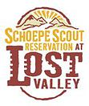**

**July 20**

**to 26th Summer Camp 2014 @ Lost Valley**

**Be part of the 50 Year Celebration!**

**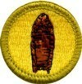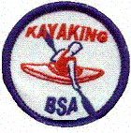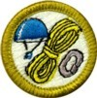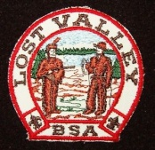**

**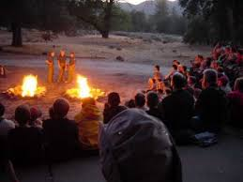**

**sq-rope**

**The Outdoor Code**

***As an American,***

***I will do my best to -***

**Be clean in my outdoor manners.   
Be careful with fire.**

**Be considerate in the outdoors.  
and**

**Be conservation minded**

sq-rope

**SCOUT IN CHARGE – YOUR RESPONSIBILITIES**

If you are the Scout -in-charge of an outing, activity, service project, Eagle project, training, patrol meeting, etc, after your event, please turn in your attendance sheet to advancement chair so the participants can get credit for attending.

The log should include date, start & stop time, location, and the list of who attended.  If it's a service/Eagle project, it should include the hours that each participant worked to the nearest half-hour.

If it's a camping trip, it should include number of nights camped for each participant.

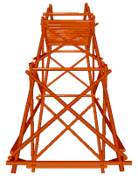It's important to turn in this information in a timely manner.  Some scouts may need these activities for advancement. You can hand deliver a paper report or email it to the advancement chair.

***Mrs. Bess, Advancement Chair***

sq-rope

**Ramblings of an old Scout Dad**

When I was a boy I had gone through Cub Scouts, earned my Arrow of Light and then bridged to Boy Scouts. My father didn’t encourage me and my Scout leaders didn’t give me a vision for what I was embarking on. I was also lazy. I quit after my first year in scouts, which I am not proud of.

Without vision or a goal in mind it’s easy to give up or be distracted by something else that sounds more entertaining or fun. So what have I learned to do when quitting seems so easy? What is the answer to keeping one on track for achieving something great and finishing the job?  Well for me, it is finding mentors who hold you accountable, inspire you and guide your actions and decision. The greatest leaders who made a difference all had great mentors; people like Dwight D. Eisenhower, Abraham Lincoln, Billy Graham, Ronald Reagan, Susan B. Anthony and Helen Keller.  These leaders didn’t achieve greatness without the shaping power of someone else who pushed, shoved, molded and stretched them.

A Scout needs to find his mentors by asking older and more experienced Scouts and leaders for help. It’s one of those “skills” not listed in the handbook.   ASKING for help is a skill. In Scouting you are not entitled to earn merit badges or rank advancements without putting in the work. The key is to ask someone older and more experienced who will help you get the job done faster and done right.

I’ll tell you, I am mentored each and every scout meeting by the men and women who go.  Sometimes I have a lousy attitude and am tired, but there are good things going on there that help me be a better father, better leader and better teacher.

Ben Franklin said***“Tell me and I forget, teach me and I may remember, involve me and I will learn”.***

**sq-rope**

**SCOUT LEADER**

**REQUIREMENTS:**

**“Keeping you informed”**

Our Boy Scout leaders should work on the items listed below during their tenure in this position. They may be asked what they did at the end of their service by Mr. M. If they do not do their job, they cannot expect to get credit for this position for advancement.

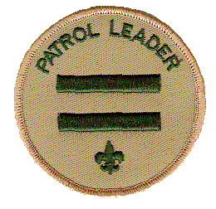

If your Scout needs guidance, he can go to Mr. Marubayashi, or his patrol advisor for help. Parents, we are listing scout responsibilities here so that you can be informed, and can remind your scout of his responsibilities too. This month we are highlighting:

**WHAT DOES A Patrol Leader DO?**

Job Description: The Patrol Leader is elected by the patrol and **leads** the patrol not simply by words or commands, but rather with Scout Spirit and by setting a good example.

Reports to: The Senior Patrol Leader

Mininum Rank: 1st Class

**Patrol Leader duties:**

* Show up to meeting on time or 15 minutes before meeting starts if have set up.
* Gets Trained by Scoutmaster.
* Plans and lead patrol meetings.
* Finds out what patrol wants to be doing and brings topic to JLC meeting to get implemented.
* Plan and lead patrols responsibility at Troop meeting. (skill, flag, game or other troop program feature event) .
* Plans and lead an activity.
* Keeps there patrol under control.
* Keep patrol members informed (not just emails either – need to talk to them in person or by phone to confirm communication is received and understood).
* Assign each patrol member a job and help them succeed. (They need at least an assistant patrol leader).
* Represent the patrol at all Junior Leaders' Council (JLC) meetings and at the annual program planning conference.
* Prepares the patrol to take part in all Troop activities.(Camporee, Scout o Rama, hikes camps etc.
* Develop the patrol spirit with a Patrol Flag, Cheer and song.
* Attends at least 2/3 of each event type during his service period.
* Work with other troop leaders to make the troop run well.
* Know what patrol members and other leaders can do.
* Sets the right example.
* Wears the Scout uniform correctly.
* Makes it a point to live by the Scout Oath and Law.

**The Patrol Leader Leads with Scout Spirit!**

**[](https://scoutnet.scouting.org/mml/a/mml2/activity/proxy.aspx?Method=OpenLink&LinkCode=scouting&MessageCode=P5CC336C4F4846D98F77253891893750)**

**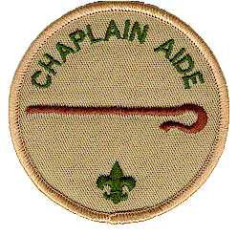Chaplain’s Aide’s**

**Inspiration of the month:**

***Psalm 111.9***

***He has sent redemption to His people; He has commanded His covenant to be forever; holy is His name, inspiring awe, reverence, and godly fear.***

The last element of the Scout Law is reverence.  A scout is reverent by honoring God through his faith.  It is important to be reverent so you stay humble.  By knowing there is always someone greater than you and more important, you won't get too cocky or self-obsessed. - ***Austin Hallman Chaplin’s Aide***

sq-rope

**The Buddy System**

The buddy system provides safety and support for the Scouts. The policy of the Boy Scouts of America is for boys to be active but in groups of no smaller than two!

sq-rope

Scout Law

***A Scout is:***

*trustworthy,*

*loyal,*

*helpful,*

*friendly,   
courteous,*

*kind,*

*obedient,*

*cheerful,*

*thrifty,  
brave,*

*clean,*

*and reverent.*

**NEW TROOP WEBSITE:**

I haven’t had much time to add content to the Troop 314 website, but the URL is:

<http://www.troop314ocbsa.scoutlander.com>

sq-rope

**Scout Trail Cooking:**

“Backpacking food for the soul”

Care of: <http://www.backpackingchef.com/>

**Hawaiian Shrimp and Rice**

Say Aloha to Hawaiian Shrimp and Rice. Dried pineapple and a pinch of coconut add just the right touch of tropical sweetness to this backpacking meal.

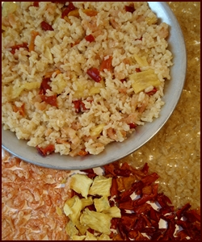**Serves 1**

**Ingredients:**

* 1/4 Cup shrimp, dried
* 1/8 Cup pineapple, dried
* 1/8 Cup bell peppers, assorted colors, dried
* 1/2 tsp coconut, dried
* 1/2 Cup dried or instant rice
* 1 Cup water

**At Home:**

Dehydrate white or brown rice by precooking and drying it using vegetable broth or use instant rice. See [Dehydrating Rice](http://www.backpackingchef.com/dehydrating-rice.html).

Pack dried pineapple and coconut flakes in separate small plastic bags. Enclose with other ingredients in plastic bag.

**Variation:** Substitute dried ham for shrimp. Omit the coconut if using ham.

To learn more about dehydrating shrimp, peppers, and pineapple for this recipe, review the [Dehydrating Meat](http://www.backpackingchef.com/dehydrating-meat.html), [Dehydrating Vegetables](http://www.backpackingchef.com/dehydrating-vegetables.html) or [Dehydrating Fruit](http://www.backpackingchef.com/dehydrating-fruit.html) pages.

**On the Trail:**

Combine all ingredients with water in pot and soak for five minutes. Light stove, bring to boil, and cook for one more minute. Insulate pot and wait ten minutes.

Thanks, Chef Glenn

sq-rope

**Tour and Activity Plans – Online!**

Council will no longer readily accept emailed, faxed or walked in Tour and Activity Plans. They want them on line. Sign into [MyScouting.org](http://ocbsa.us1.list-manage2.com/track/click?u=1b4789f7f263125755c4f4b12&id=0b9909c68e&e=7b33b16584) .  
  
When online, you no longer have to collect signatures. Complete the plan and certify that any missing requirements will be completed before the trip begins. When you submit the plan, an email will be sent to your council, chartered organization, committee chair, and your designated emergency contact.

sq-rope

**Hall Use at American Legion**

**Post 555**

If you would like to have an event at the Post – from a training day, a car wash or an Eagle Court of Honor, please e-mail Mrs. Daly early! At dalyracing@verizon.net to confirm the hall is available and to make reservations.

Mrs. Daly is our troop Chartered Organization Rep. She is also a member of the Women's Auxiliary of Post 555. Her phone is (714) 892-8508 for any follow up that is needed.

sq-rope

**BSA Climbing Resources**

<https://sites.google.com/site/bsaclimbinstclass/materials>

sq-rope

|  |
| --- |
| *JOKES, JOKES, JOKES*  ***HaHaHave you heard this one?*** |
| JOKES  What kind of cheese goes to church?  Swiss, its Holy !  Why couldn't the snake talk? He had a frog in his throat.  What did the frog order at McDonald's?  French flies and a diet Croak  What's red and green and goes 100 miles an hour?  A frog in a blender.  What do you get if you add milk?  Frog nog!  What happens if you drink frog nog?  You Croak!  What's black and white and green?  A frog sitting on a newspaper.  What's white on the outside, and green on the inside?  A frog sandwich!  Why did the frog go to the bank with a gun?  He was going to robbit. |
| One more painful Joke:  A boy was crossing a road one day when a frog called out to him and said, 'If you kiss me, I'll turn into a beautiful Princess.' The boy picked up the frog and put it in his pocket.  The frog said, 'Hey, if you kiss me and turn me back into a beautiful Princess, I'll love you forever.' The boy took the frog out of his pocket, smiled at it, and put it back in his pocket.  The frog yelled, 'If you kiss me and turn me back into a Princess, I'll clean your house, cook for you, and love you forever.' The boy took the frog out, smiled at it, and put it back.  Finally the frog asked, 'What is it? I've told you I'm a beautiful Princess, that I'll cook and clean for you and love you forever. Why won't you kiss me?'  The boy said, 'Look, I'm just a cub scout. I don't even like girls, but a talking frog is really cool. |

**The Scout Oath**

***On my honor I will do my best  
To do my duty to God and my country and to obey the Scout Law;***

***To help other people at all times;***

***To keep myself physically strong, mentally awake, and morally straight.***

***“It’s the spirit within, not the veneer without, that makes a man.”***

* ***Robert Baden-Powell***

***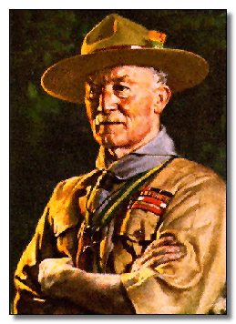***

**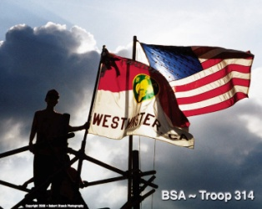**

**TROOP 314 -**

**TOWER ABOVE THE REST !**

To contact the Newsletter Editor or for more information about Troop 314

Send me a note at T314news@live.com -Thanks, Mr. Pearson

Troop 314 Tower Picture (paint)